CLOCKWISE ROTATION OF STEPPER MOTOR USING 8051 USING PROTEUS
AIM:
To write an assembly language program to rotate the Stepper Motor in clockwise direction in 8051 using Proteus

SOFTWARE REQUIRED:
- Proteus 8 software.

PROGRAM:
ORG 0000H ; Starting address
UP:
MOV P2, #08H ; Step 1: Coil 4 = ON, others OFF (Clockwise direction)
ACALL DELAY ; Delay for a short period
MOV P2, #04H ; Step 2: Coil 3 = ON, others OFF
ACALL DELAY ; Delay for a short period
MOV P2, #02H ; Step 3: Coil 2 = ON, others OFF
ACALL DELAY ; Delay for a short period
MOV P2, #01H ; Step 4: Coil 1 = ON, others OFF
ACALL DELAY ; Delay for a short period
SJMP UP ; Repeat the sequence for continuous rotation

DELAY:
MOV R4, #18 ; Outer delay loop counter
H1:
MOV R3, #255 ; Inner delay loop counter
H2:
DJNZ R3, H2 ; Decrement and loop if not zero
DJNZ R4, H1 ; Decrement and loop if not zero
RET ; Return from delay subroutine

END

CIRCUIT DIAGRAM:

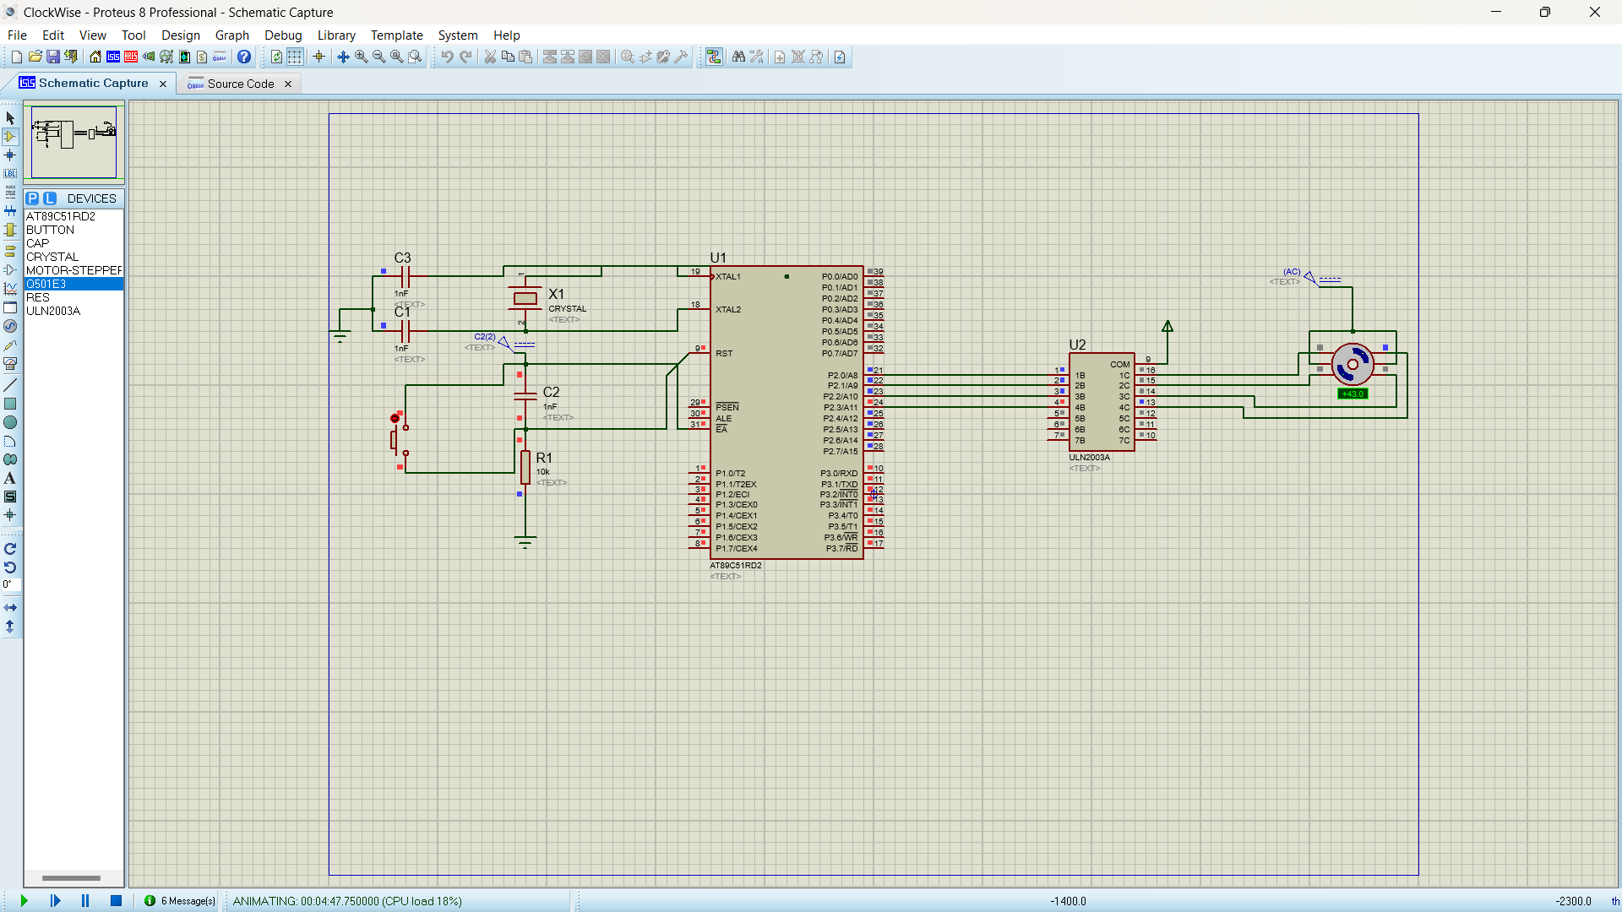

OUTPUT:
The stepper motor is rotating in clockwise direction in steps.

RESULT:
Thus, the program has been successfully verified and executed.

